|  |  |  |
| --- | --- | --- |
| events_cat2 | CS151 – Programming Assignment 3  Fun with Alice and Dr. Seuss | events_kids |

Alice and her friends like to play games with Dr. Suess even though Alice thinks his stories are a bit strange. The friends all gather and take turns reciting words from a section of Dr. Seuss.

To play the game, the friends all line up one after the other and are assigned numbers from the set of the natural numbers[[1]](#footnote-1). Since they are all the creations of logical and educated authors, they follow the well ordering principle of the natural numbers. Hence, the first friend would be number 1, the second would be number 2, and so on up the last friend who would be *n*.

The friends would then take turns reciting words from a Dr. Seuss rhyme until the rhyme was finished. When they reach the end of the line, they start back at the beginning. The person who spoke the last word would be eliminated from play and the game would begin anew until only one person was left. That person would be the winner of the game.

For example, if there are six people playing and the rhyme is “Cat in the Hat” (4 words), play would proceed as follows:



**Figure 1 – An Example Game**

Being the product of a mathematician’s mind, Alice is highly competitive and does not like to lose, particularly to her friends.

For this assignment, you need to write a program that creates a circular linked list of nodes to determine where Alice should stand for a particular number of friends (up to 10) given a particular rhyme.

A circular linked list is a linked list where the link field of the last node in the list refers to the node that is at the head of the list. Your program should simulate the elimination process by deleting the node that corresponds to the person eliminated by the last word of the rhyme at each step in the process[[2]](#footnote-2).

For input, you will be given a file with a rhyme. For each particular rhyme, you need to determine where Alice needs to stand in line in order to win the game for any given number of friends between 2 and 10. For each input rhyme, save your results to a file.

# Base Assignment (To Turn In)

We will use the four step process in order to make sure that we get this assignment right.

##### Step 1 – Understand the Problem (5 Points)

Alice and five friends decide to play the game using the rhyme “Sam I Am”. Work this problem out by hand (like Figure 1) and turn in your results October 11, 2017. If you are having trouble understanding what to do, work out different examples to understand how the game works.

##### Step 2 – Plan (15 Points)

Your program plan should consist of the following items.

1. A description of your program design that indicates how you will design your program to meet the assignment requirements. You should indicate:
   1. The **variables** that your program will use and how you will name and use them.
   2. The **major functions** your program will have along with descriptions of their parameters.
   3. Descriptions of the **algorithms** your program will use.

**Note:** Don’t be afraid to use visual representations and diagrams.

1. Your program design description should also indicate how your solution will be easily understood by the user and by future coders.

Submit your plan by October 11, 2017.

##### Step 3 – Implement (70 Points)

Your code should have appropriate comments to explain the program and the code. It should be written in a consistent and readable form and compile without errors or warnings.

Submit your code October 23, 2017.

##### Step 4 – Test (10 Points)

A brief set of test plans. Here, you should indicate what type of test cases you will run for your program and what potential errors these test plans are likely to trap. For example, you may want a test that deals with the possibility that no one wants to play the game and you have to process a null list.

Submit your test plans along with the code on October 23, 2017.

## Bonus (1 Point)

According to T.S. Eliot, “The naming of cats is a difficult matter, It isn't just one of your holiday games.” Allow your game to incorporate the names of the characters who are playing the game.

## Bonus (10 Points)

The Mad Hatter, White Rabbit and Cheshire Cat decide that they like playing the game, but want to make it a bit more curiouser and curiouser. They decide to use a doubly linked circular list to mirror the table at their tea party.

In addition, they move forward through the list for odd lines of the rhyme and backward for even numbered lines in order to be contrary wise. Implement this data structure in your code and determine the position that Alice needs to take in order to win their game under their rules in addition to where she needs to be to win the original game.

## Some Test Data

The following page has some test data that you can use.

CS Department Motto

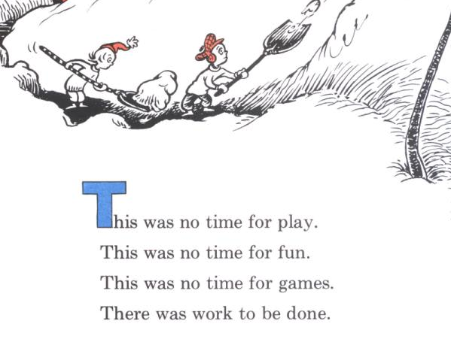

1. Although sometimes no one wants to play, so you will need to deal with that possibility in your program. [↑](#footnote-ref-1)
2. You need to consider the possibility that you might have to delete the head of the linked list. [↑](#footnote-ref-2)